JEE 102

# Question 1

what is A in the following reaction ?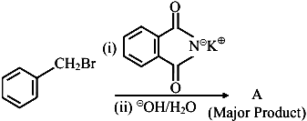

1. 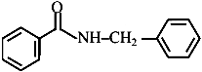
2. image
3. 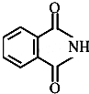
4. image

# Question 2

Which one of the products of the following reactions does not react with Hinsberg reagent to form sulphonamide? [25 Jul 2021]

1. 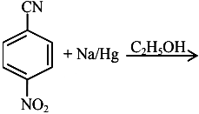
2. 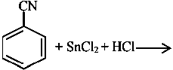
3. 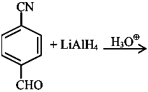
4. 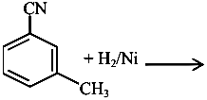

# Question 3

An organic compound "A" on treatment with benzene sulphonyl chloride gives compound $B.B$ is soluble in dil. $NaOH$ solution. Compound $A$ is______________.

$C_{6}H_{5}-N-{\left({CH}_{3}\right)}_{2}$

$C_{6}H_{5}-{NHCH}_{2}{CH}_{3}$

$C_{6}H_{5}-{CH}_{2}{NHCH}_{3}$

$C_{6}H_{5}-CH-{NH}_{2}$

# Question 4

The number of nitrogen atoms in a semicarbazone molecule of acetone is_____________.

# Question 5

The total number of reagents from those given below, that can convert nitrobenzene into aniline is _______________ (Integer answer)

|  |  |
| --- | --- |
|  |  |
|  | Raney nickel |

# Question 6

A primary aliphatic amine on reaction with nitrous acid in cold ( $273 K)$ and there after raising temperature of reaction mixture to room temperature (298 K), gives.

1. nitrile
2. alcohol
3. diazonium salt
4. secondary amine

# Question 7

Choose the correct colour of the product for the following reaction.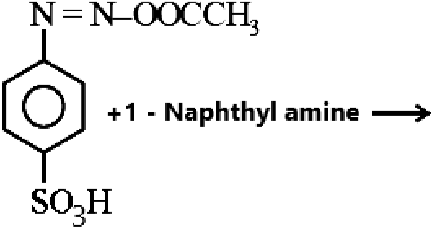

1. Yellow
2. White
3. Red
4. Blue

# Question 8

Number of isomeric aromatic amines with molecular formula $C_{8}H_{11} N$, which can be synthesized by Gabriel Phthalimide synthesis is ___________.  [6-Apr-2023]

# Question 9

Given below are two statements :Statement I : Aniline is less basic than acetamide.Statement II : In aniline, the lone pair of electrons on nitrogen atom is delocalised over benzene ring due to resonance and hence less available to a proton.Choose the most appropriate option ;

1. Statement I is true but statement II is false.
2. Statement I is false but statement II is true.
3. Both statement I and statement II are true.
4. Both statement I and statement II are false.

# Question 10

The most appropriate reagent for conversion of $C_{2}H_{5}CN$ into ${CH}_{3}{CH}_{2}{CH}_{2}{NH}_{2}$ is:

${NaBH}_{4}$

${CaH}_{2}$

1. LiAl H $​_{4}$

$Na\left(CN\right){BH}_{3}$

# Question 11

The number of primary amines of formula $C_{4}H_{11} N$ is ?

# Question 12

what is A in the following reaction ?

1. 
2. image
3. 
4. image

# Question 13

Match List I with List II.

| List-I | List-II |
| --- | --- |
| A. Benzenesulphonyl Chloride | I. Test for primary amines |
| B. Hoffmann bromamide reaction | II. Anti Saytzeff |
| C. Carbylamine reaction | III. Hinsberg reagent |
| D. Hoffmann orientation | IV. Known reaction of Isocyanates |

Choose the correct answer from the options given below:

1. A-IV, B-III, C-II, D-I
2. A-IV, B-II, C-I, D-II
3. A-III, B-IV, C-I, D-II
4. A-IV, B-III, C-I, D-II

# Question 14

Compound $A$ is converted to $B$ on reaction with ${CHCl}_{3}$ and $KOH$. The compound $B$ is toxic and can be decomposed by C. A, B and $C$ respectively are :

1. primary amine, nitrile compound, conc.
2. secondary amine, isonitrile compound, conc. $NaOH$
3. primary amine, isonitrile compound, conc. $HCl$
4. secondary amine, nitrile compound, conc. $NaOH$

# Question 15

The major product formed in the following reaction is.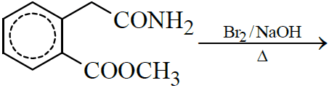

1. 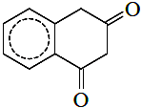
2. 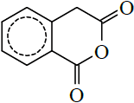
3. 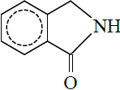
4. 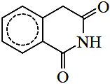

# Question 16

Choose the correct colour of the product for the following reaction.

1. Yellow
2. White
3. Red
4. Blue

# Question 17

Number of isomeric aromatic amines with molecular formula $C_{8}H_{11} N$, which can be synthesized by Gabriel Phthalimide synthesis is ___________.  [6-Apr-2023]

# Question 18

Given below are two statements :Statement I : In Hofmann degradation reaction, the migration of only an alkyl group takes place from carbonyl carbon of the amide to the nitrogen atom.Statement II : The group is migrated in Hofmann degradation reaction to electron deficient atom.In the light of the above statements, choose the most appropriate answer from the options given below:

1. Both Statement I and Statement II are correct.
2. Both Statement I and Statement II are incorrect.
3. Statement I is correct but Statement II is incorrect.
4. Statement I is incorrect but Statement II is correct.

# Question 19

During halogen test, sodium fusion extract is boiled with concentrated ${HNO}_{3}$ to

1. remove unreacted sodium
2. decompose cyanide or sulphide of sodium
3. extract halogen from organic compound
4. maintain the $pH$ of extract.

# Question 20

A compound with molecular mass 180 is acylated with ${CH}_{3}COCl$ to get a compound with molecular mass 390 . The number of amino groups present per molecule of the former compound is:

# Question 21

The product A formed in the following reaction is: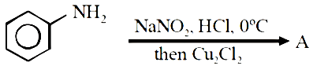

1. 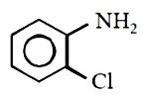
2. 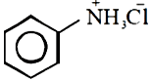
3. 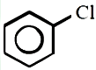
4. 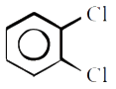

# Question 22

What is the correct name for a molecule that has two amino groups in opposing (para) locations around a benzene ring?

1. Benzenediamine
2. Benzene-1,4-diamine
3. p-Aminoaniline
4. 4-Aminobenzenamine

# Question 23

Which of the following is not a correct statement for primary aliphatic amines?

1. The intermolecular association in primary amines is less than the intermolecular association in secondary amines.
2. Primary amines on treating with nitrous acid solution form corresponding alcohols except methyl amine.
3. Primary amines are less basic than the secondary amines.
4. Primary amines can be prepared by the gabriel phthalimide synthesis.

# Question 24

what is A in the following reaction ?

1. 
2. image
3. 
4. image

# Question 25

An organic compound "A" on treatment with benzene sulphonyl chloride gives compound $B.B$ is soluble in dil. $NaOH$ solution. Compound $A$ is______________.

$C_{6}H_{5}-N-{\left({CH}_{3}\right)}_{2}$

$C_{6}H_{5}-{NHCH}_{2}{CH}_{3}$

$C_{6}H_{5}-{CH}_{2}{NHCH}_{3}$

$C_{6}H_{5}-CH-{NH}_{2}$

# Question 26

A primary aliphatic amine on reaction with nitrous acid in cold ( $273 K)$ and there after raising temperature of reaction mixture to room temperature (298 K), gives.

1. nitrile
2. alcohol
3. diazonium salt
4. secondary amine

# Question 27

Match List I with List II.

| List-I | List-II |
| --- | --- |
| A. Benzenesulphonyl Chloride | I. Test for primary amines |
| B. Hoffmann bromamide reaction | II. Anti Saytzeff |
| C. Carbylamine reaction | III. Hinsberg reagent |
| D. Hoffmann orientation | IV. Known reaction of Isocyanates |

Choose the correct answer from the options given below:

1. A-IV, B-III, C-II, D-I
2. A-IV, B-II, C-I, D-II
3. A-III, B-IV, C-I, D-II
4. A-IV, B-III, C-I, D-II

# Question 28

Compound $A$ is converted to $B$ on reaction with ${CHCl}_{3}$ and $KOH$. The compound $B$ is toxic and can be decomposed by C. A, B and $C$ respectively are :

1. primary amine, nitrile compound, conc.
2. secondary amine, isonitrile compound, conc. $NaOH$
3. primary amine, isonitrile compound, conc. $HCl$
4. secondary amine, nitrile compound, conc. $NaOH$

# Question 29

The major product formed in the following reaction is.

1. 
2. 
3. 
4. 

# Question 30

Given below are two statements :Statement I : In Hofmann degradation reaction, the migration of only an alkyl group takes place from carbonyl carbon of the amide to the nitrogen atom.Statement II : The group is migrated in Hofmann degradation reaction to electron deficient atom.In the light of the above statements, choose the most appropriate answer from the options given below:

1. Both Statement I and Statement II are correct.
2. Both Statement I and Statement II are incorrect.
3. Statement I is correct but Statement II is incorrect.
4. Statement I is incorrect but Statement II is correct.

# Question 31

Given below are two statements :Statement I : Aniline is less basic than acetamide.Statement II : In aniline, the lone pair of electrons on nitrogen atom is delocalised over benzene ring due to resonance and hence less available to a proton.Choose the most appropriate option ;

1. Statement I is true but statement II is false.
2. Statement I is false but statement II is true.
3. Both statement I and statement II are true.
4. Both statement I and statement II are false.

# Question 32

The decreasing order of basicity of the following amines is: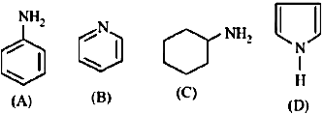

$\left(A\right)>\left(C\right)>\left(D\right)>\left(B\right)$

$\left(C\right)>\left(A\right)>\left(B\right)>\left(D\right)$

$\left(B\right)>\left(C\right)>\left(D\right)>\left(A\right)$

$\left(C\right)>\left(B\right)>\left(A\right)>\left(D\right)$

# Question 33

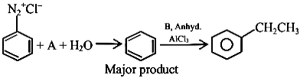the chemical reactions given above $A$ and $B$ respectively are:

1. $H_{3}{PO}_{2}$ and ${CH}_{3}{CH}_{2}Cl$
2. ${CH}_{3}{CH}_{2}OH$ and $H_{3}{PO}_{2}$
3. $H_{3}O_{2}$ and ${CH}_{3}{CH}_{2}OH$
4. ${CH}_{3}{CH}_{2}Cl$ and $H_{3}{PO}_{2}$

# Question 34

$C_{7}H_{9}N∣$ has how many isomeric forms that contain a benzene ring?

# Question 35

The total number of electrons around the nitrogen atom in amines are,

# Question 36

The number of primary amines of formula $C_{4}H_{11} N$ is ?

# Question 37

The product A formed in the following reaction is:

1. 
2. 
3. 
4. 

# Question 38

In the reaction of hypobromite with amide, the carbonyl carbon is lost as

${CO}_{3}​^{2-}$

${HCO}_{3}​^{-}$

${CO}_{2}$

$CO$

# Question 39

An organic compound "A" on treatment with benzene sulphonyl chloride gives compound $B.B$ is soluble in dil. $NaOH$ solution. Compound $A$ is______________.

$C_{6}H_{5}-N-{\left({CH}_{3}\right)}_{2}$

$C_{6}H_{5}-{NHCH}_{2}{CH}_{3}$

$C_{6}H_{5}-{CH}_{2}{NHCH}_{3}$

$C_{6}H_{5}-CH-{NH}_{2}$

# Question 40

Match List I with List II.

| List-I | List-II |
| --- | --- |
| A. Benzenesulphonyl Chloride | I. Test for primary amines |
| B. Hoffmann bromamide reaction | II. Anti Saytzeff |
| C. Carbylamine reaction | III. Hinsberg reagent |
| D. Hoffmann orientation | IV. Known reaction of Isocyanates |

Choose the correct answer from the options given below:

1. A-IV, B-III, C-II, D-I
2. A-IV, B-II, C-I, D-II
3. A-III, B-IV, C-I, D-II
4. A-IV, B-III, C-I, D-II

# Question 41

Consider the following sequence of reaction :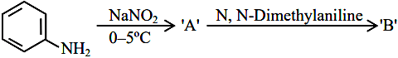product ’ ’ is :

1. image
2. 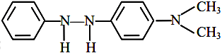
3. 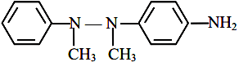
4. image

# Question 42

Number of isomeric aromatic amines with molecular formula $C_{8}H_{11} N$, which can be synthesized by Gabriel Phthalimide synthesis is ___________.  [6-Apr-2023]

# Question 43

Given below are two statements :Statement I : In Hofmann degradation reaction, the migration of only an alkyl group takes place from carbonyl carbon of the amide to the nitrogen atom.Statement II : The group is migrated in Hofmann degradation reaction to electron deficient atom.In the light of the above statements, choose the most appropriate answer from the options given below:

1. Both Statement I and Statement II are correct.
2. Both Statement I and Statement II are incorrect.
3. Statement I is correct but Statement II is incorrect.
4. Statement I is incorrect but Statement II is correct.

# Question 44

During halogen test, sodium fusion extract is boiled with concentrated ${HNO}_{3}$ to

1. remove unreacted sodium
2. decompose cyanide or sulphide of sodium
3. extract halogen from organic compound
4. maintain the $pH$ of extract.

# Question 45

Given below are two statements :Statement I : Aniline is less basic than acetamide.Statement II : In aniline, the lone pair of electrons on nitrogen atom is delocalised over benzene ring due to resonance and hence less available to a proton.Choose the most appropriate option ;

1. Statement I is true but statement II is false.
2. Statement I is false but statement II is true.
3. Both statement I and statement II are true.
4. Both statement I and statement II are false.

# Question 46

The decreasing order of basicity of the following amines is:

$\left(A\right)>\left(C\right)>\left(D\right)>\left(B\right)$

$\left(C\right)>\left(A\right)>\left(B\right)>\left(D\right)$

$\left(B\right)>\left(C\right)>\left(D\right)>\left(A\right)$

$\left(C\right)>\left(B\right)>\left(A\right)>\left(D\right)$

# Question 47

$C_{7}H_{9}N∣$ has how many isomeric forms that contain a benzene ring?

# Question 48

The number of primary amines of formula $C_{4}H_{11} N$ is ?

# Question 49

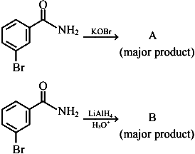the above reactions, product $A$ and product $B$ respectively are:

1. 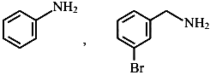
2. 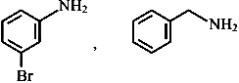
3. image
4. 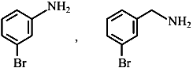

# Question 50

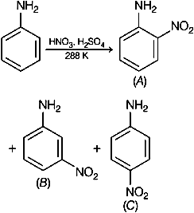the given reaction, percentage yield of,

$\left(C\right)>\left(A\right)>\left(B\right)$

$\left(B\right)>\left(C\right)>\left(A\right)$

$\left(A\right)>\left(C\right)>\left(B\right)$

$\left(C\right)>\left(B\right)>\left(A\right)$

# Question 51

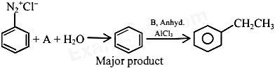the chemical reactions given above $A$ and $B$ respectively are:

1. $H_{3}{PO}_{2}$ and ${CH}_{3}{CH}_{2}Cl$
2. ${CH}_{3}{CH}_{2}OH$ and $H_{3}{PO}_{2}$
3. $H_{3}O_{2}$ and ${CH}_{3}{CH}_{2}OH$
4. ${CH}_{3}{CH}_{2}Cl$ and $H_{3}{PO}_{2}$

# Question 52

Given below are two statements :Statement I: Aniline reacts with con. $H_{2}{SO}_{4}$ followed by heating at $453-473 K$ gives p-aminobenzene sulphonic acid, which gives blood red colour in the ’Lassaigne’s test’.II: In Friedel - Craft’s alkylation and acylation reactions, aniline forms salt with the ${AlCl}_{3}$ catalyst.to this, nitrogen of aniline aquires a positive charge and acts as deactivating group.the light of the above statements, choose the correct answer from the options given below :

1. Statement I is false but statement II is true
2. Both statement I and statement II are false
3. Statement I is true but statement II is false
4. Both statement I and statement II are true

# Question 53

An organic compound "A" on treatment with benzene sulphonyl chloride gives compound $B.B$ is soluble in dil. $NaOH$ solution. Compound $A$ is______________.

$C_{6}H_{5}-N-{\left({CH}_{3}\right)}_{2}$

$C_{6}H_{5}-{NHCH}_{2}{CH}_{3}$

$C_{6}H_{5}-{CH}_{2}{NHCH}_{3}$

$C_{6}H_{5}-CH-{NH}_{2}$

# Question 54

A primary aliphatic amine on reaction with nitrous acid in cold ( $273 K)$ and there after raising temperature of reaction mixture to room temperature (298 K), gives.

1. nitrile
2. alcohol
3. diazonium salt
4. secondary amine

# Question 55

Primary, secondary and tertiary amines can be separated using.

1. para-toluene sulphonyl chloride
2. chloroform and $KOH$
3. benzene sulphonic acid
4. acetyl amide

# Question 56

The major product formed in the following reaction is.

1. 
2. 
3. 
4. 

# Question 57

Consider the following sequence of reaction :product ’ ’ is :

1. image
2. 
3. 
4. image

# Question 58

The correct order in aqueous medium of basic strength in case of methyl substituted amines is :

${Me}_{2}NH>{MeNH}_{2}>{Me}_{3} N>{NH}_{3}$

${Me}_{2}NH>{Me}_{3} N>{MeNH}_{2}>{NH}_{3}$

${NH}_{3}>{Me}_{3} N>{MeNH}_{2}>{Me}_{2}NH$

${Me}_{3} N>{Me}_{2}NH>{MeNH}_{2}>{NH}_{3}$

# Question 59

Given below are two statements :Statement I : In Hofmann degradation reaction, the migration of only an alkyl group takes place from carbonyl carbon of the amide to the nitrogen atom.Statement II : The group is migrated in Hofmann degradation reaction to electron deficient atom.In the light of the above statements, choose the most appropriate answer from the options given below:

1. Both Statement I and Statement II are correct.
2. Both Statement I and Statement II are incorrect.
3. Statement I is correct but Statement II is incorrect.
4. Statement I is incorrect but Statement II is correct.

# Question 60

The most appropriate reagent for conversion of $C_{2}H_{5}CN$ into ${CH}_{3}{CH}_{2}{CH}_{2}{NH}_{2}$ is:

${NaBH}_{4}$

${CaH}_{2}$

1. LiAl H $​_{4}$

$Na\left(CN\right){BH}_{3}$

# Question 61

the given reaction, percentage yield of,

$\left(C\right)>\left(A\right)>\left(B\right)$

$\left(B\right)>\left(C\right)>\left(A\right)$

$\left(A\right)>\left(C\right)>\left(B\right)$

$\left(C\right)>\left(B\right)>\left(A\right)$

# Question 62

the chemical reactions given above $A$ and $B$ respectively are:

1. $H_{3}{PO}_{2}$ and ${CH}_{3}{CH}_{2}Cl$
2. ${CH}_{3}{CH}_{2}OH$ and $H_{3}{PO}_{2}$
3. $H_{3}O_{2}$ and ${CH}_{3}{CH}_{2}OH$
4. ${CH}_{3}{CH}_{2}Cl$ and $H_{3}{PO}_{2}$